Tower Dental located in Blackpool. Offering a range of Dental Treatments.

Orthodontics is a specialized branch of dentistry focused on diagnosing, preventing, and treating [Dental practice](https://www.facebook.com/profile.php?id=61558089747628) and facial irregularities. The most common issues addressed by orthodontists include misaligned teeth, improper bites (overbite, underbite, crossbite), and jaw problems. Treatment options range from traditional metal braces to more modern solutions like clear aligners (e.g., Invisalign), each designed to gradually shift teeth into the desired position.

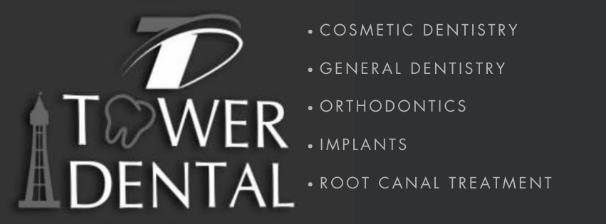

Key Benefits of Orthodontic Treatment:

Improved Oral Health: Properly aligned teeth are easier to clean, reducing the risk of tooth decay, gum disease, and other oral health issues.

Enhanced Aesthetics: Straight teeth contribute to a more attractive smile, boosting self-confidence.

Better Functionality: Correcting bite issues can improve chewing, speech, and overall comfort.

Treatment Process:

Orthodontic treatment typically begins with a thorough examination, including X-rays and dental impressions. The orthodontist will then create a personalized treatment plan, which may involve braces, aligners, or other appliances. Regular check-ups are essential throughout the treatment period, which can last from several months to a few years, depending on the complexity of the case.

The Role of Early Intervention:

For children, early orthodontic evaluation (around age 7) is crucial. Early detection and treatment can guide the growth of the jaw and the emerging permanent teeth, preventing more severe problems later on.

[Orthodontics](https://www.facebook.com/profile.php?id=61558089747628) plays a vital role in achieving both functional and aesthetic dental health. With advancements in treatment options, patients of all ages can benefit from improved smiles and oral well-being.